* 4th Week

**Ausnutria: Milk Powder from the World “Golden Milk Source Belt”**

**Machine Translation**:

[English](https://www.wipo.int/ipadvantage/en/details.jsp?id=12105)

* **Name**: Ausnutria
* **Country / Territory**: China
* **IP right(s)**: Trademarks
* **Date of publication**: July 26, 2021
* **Last update**: July 26, 2021

Ausnutria was established in the autumn of 2003, in Changsha City, China, in response to a time when dairy resources were extremely scarce. After growing its business for 17 years, Ausnutria has now become a global dairy company with a complete industrial chain from milk collection, production to market sales, owning 8 overseas factories, and developing sale service networks in more than 60 countries and regions worldwide.

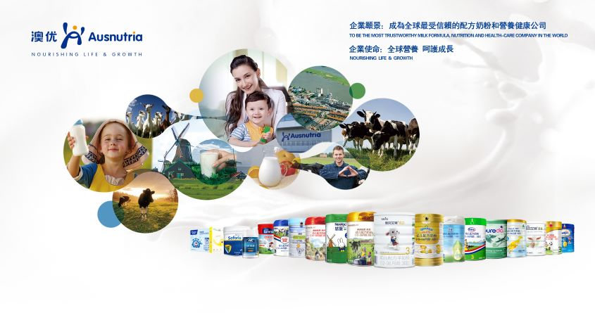(PHOTO: © AUSNUTRIA DAIRY CORPORATION LTD.)

Ausnutria was listed on the main board of the Hong Kong Stock Exchange in 2009. As of December 31, 2019, the total number of employees of Ausnutria around the world was 4,510, of which 788 based overseas, (i.e 17.5% of all staff). Over 12% of Ausnutria’s sales revenue comes from its overseas markets. When it comes to vertical expansion, in areas including global supply, scientific research, talents, brand sales, and more, Ausnutria has become one of the most internationalized companies in China's dairy industry.

The international development of Ausnutria is a microcosm of the internationalization process of the Chinese dairy industry. This is a story of the development process of brand innovation and upgrading.

**Strengthening brand building and striving to establish an international dairy brand**

A brand is the soul of a company and leads to its development and even survival. Without it, companies may lack vitality and sustainability. Since its inception, Ausnutria has taken quality as the pillar for its brand concept: "Be Fearless, For Excellence". It is central to the company, which has built an international dairy brand with high standards, high starting points and high requirements.

In terms of milk sources, Ausnutria insists on using world-class ones. Since its establishment, the company has chosen Australia as its milk source region, and has set further milk sources among first-class overseas production areas until today. At present, Ausnutria has built and acquired 8 factories across the Netherlands, Australia and New Zealand. It is the only dairy company that has spread strategically across the world's “golden milk source belt” in this manner.



Ausnutria’s Pluto and Hector plant in the Netherlands (Photo: © Ausnutria Dairy Corporation Ltd.)

In the field of research and development (R&D) and innovation, Ausnutria insists on cooperating with top R&D institutions both in China and abroad to build its own global intellectual property chain. At present, Ausnutria has formed a global R&D system based on Ausnutria Institute of Food and Nutrition, and has established an international R&D team including more than 180 researchers with doctoral degrees, as well as other dairy experts.



Ausnutria Institute of Food and Nutrition (Photo: © Ausnutria Dairy Corporation Ltd.)

As for quality control, Ausnutria always adheres to the highest international standards. It adopts 8 major quality management systems such as ISO9001, HACCP, GMP, Integrity (a quality system in China) to ensure its products’ quality and safety. It has also invested more than ¥40 million to establish an electronic traceability system covering the entire quality process to realize tracking from farm to table.

Regarding brand building, Ausnutria insists on adopting a multi-brand strategy to achieve differentiated brand distinction. The company has achieved multi-brand strategic growth through differentiating the positioning of products, the base powder and formulation of cow and goat milk powders, and the production areas as well as plants. It has built Kabrita as the world's number one goat milk powder brand, established Hyproca 1897 as an ultra-high-end milk powder brand imported from the Netherlands, and set up Neolac as a high-end organic milk powder brand certified by the European Union, the Netherlands, and China.

From the perspective of international development, Ausnutria insists on participating in global competition through subdivisions. After acquiring the century-old Dutch dairy company Hyproca Group in 2011 and grafting its resources such as pasture, milk source, R&D, production process, and technology, Ausnutria has determined its differentiated development path as "taking goat milk powder as a breakthrough, firstly becoming an international leader in goat milk powder and then gradually growing into a world-class milk powder company". In 2011, Ausnutria launched its goat milk powder brand "Kabrita", which was simultaneously sold globally while entering the Chinese market. After several years’ development, Kabrita brand has accounted for more than 60% of imported infant goat milk powder sales from 2018 to 2019 for two consecutive years, and has been sold in more than 60 countries and regions including China, Russia, Europe, the Middle East, and North America.

**Taking advantage of the Madrid System to accelerate the pace of Ausnutria’s internationalization strategy**

Through acquiring the Dutch Hyproca Group in 2011, acquiring Australian nutrition company Nutrition Care in 2016, establishing a joint venture (Pure Nutrition Ltd) with New Zealand company Westland, and acquiring the milk powder factory Australian Dairy Park and Oz Farm brand in Australia in 2017, Ausnutria successfully established its international layout globally. But at the same time, with the addition of business sub-units and continuous expansion into overseas markets, Ausnutria accumulated more trademark and brand assets with an increasingly urgent demand for international brand protection.

In 2018, Ausnutria officially updated and released its third-generation corporate logo. "Based on the new logo, we’ll comprehensively integrate our global businesses and unify our global image," Yan Weibin, Chairman of Ausnutria, said. He also expressed that business in all regions of the world would gradually use the corporate name "澳优Ausnutria" as a whole to convey the corporate confidence of " One Ausnutria, One Dream, and One Voice".



The Launching Conference of Ausnutria’s Third-Generation Corporate Logo (Photo: © Ausnutria Dairy Corporation Ltd.)

The first problem that the company solved was the protection of the "Ausnutria" trademark overseas. Only by protecting the trademark can it be used safely on the international market. However, registering country by country would have been a too considerable a workload for a company like Ausnutria whose business volume spans across all parts of the world, and the Madrid System solved this problem.

The Madrid System has the advantages of offering simple procedures, low cost, and time efficiency. It also covers over 120 countries, which include the countries and regions where Ausnutria’s main overseas markets are located. In November 2017, Ausnutria filed an application through the Madrid System for its third-generation logo combination of "澳优Ausnutria" covering 15 countries including Australia, the United Kingdom, the United States of America, and New Zealand, and received its registration in May 2018. Through the "fast track" registration process of the Madrid System, Ausnutria was able to complete the application and promotion of its new logo globally within a short period of time, and hence took the first step of its "One Ausnutria, One Dream, One Voice" strategic plan.

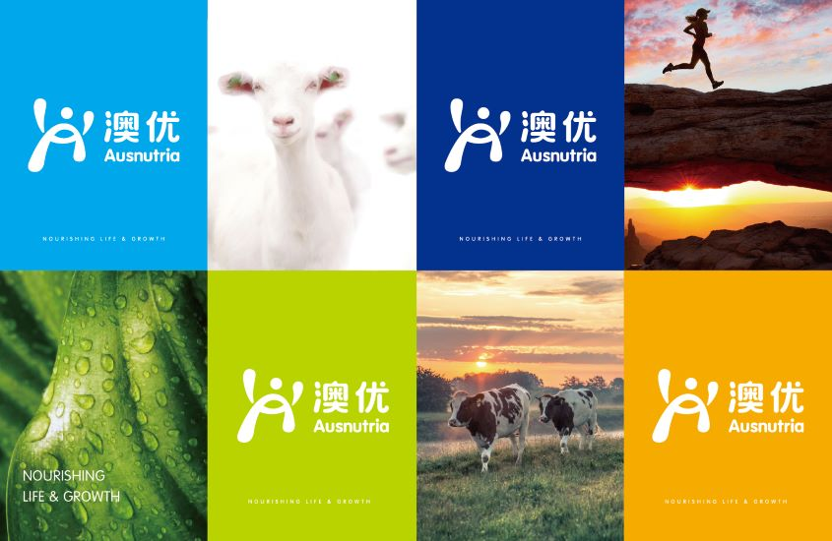(PHOTO: © AUSNUTRIA DAIRY CORPORATION LTD.)

**Ausnutria and the WIPO Madrid System in practice**

**Kabrita (International Registration Numbers:**[**1545694**](https://www3.wipo.int/madrid/monitor/en/showData.jsp?ID=ROM.1545694)**,**[**1543623**](https://www3.wipo.int/madrid/monitor/en/showData.jsp?ID=ROM.1543623)**,**[**1221861**](https://www3.wipo.int/madrid/monitor/en/showData.jsp?ID=ROM.1221861)**,**[**1220068**](https://www3.wipo.int/madrid/monitor/en/showData.jsp?ID=ROM.1220068)**and**[**1098039**](https://www3.wipo.int/madrid/monitor/en/showData.jsp?ID=ROM.1098039)**)**

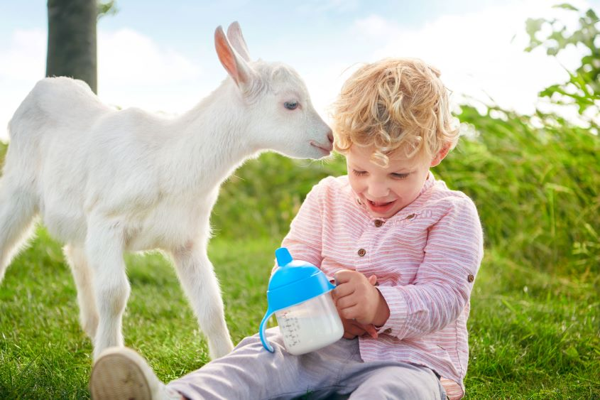(PHOTO: © AUSNUTRIA DAIRY CORPORATION LTD.)

Up to now, Ausnutria owns nearly 170 valid domestic and international trademark registrations, of which 88 are international trademarks registered through the Madrid System. Among them, "Kabrita", a goat milk powder brand under Ausnutria, which has been sold to more than 60 countries and regions, also benefits from the Madrid System to efficiently achieve global trademark protection and utilization. At present, Kabrita has already become the world's No. 1 goat milk brand in terms of both sales and popularity and has become a veritable international leader in goat milk powder segment. Other trademarks such as "Ausnutria" and "Neolac" have since also gradually become popular, international brands recognized by consumers around the world with the expansion of business overseas.

**A strong IP strategy for an even stronger global expansion**

Innovation is the first driving force for development, and protecting intellectual property rights means protecting innovation. Benefiting from the Madrid System’s international trademark registration and international intellectual property protection, Ausnutria has developed rapidly. In the future, the company aims to further strengthen its intellectual property and brand strategy, increase the brand value and impact of products and services and to keep actively registering its marks through the Madrid System. Ausnutria will continue to improve its international trademark registration and utilization to further promote China's dairy industry to the world, and to make greater contributions to the health of all mankind.